Cognitive analysis of Elderly persons with AI and VR

**Project Team**

* Aissatou Diallo
* Dinesh Garnayak
* Sehtab Hossain

**Motivation and Significance**

Elderly people lose cognitive ability as they grow older due to age, Alzheimer's, dementia, etc. Some common causes are medication side effects, depression, and dementia.[2] However it's complicated for them or their close relatives to identify the issue early enough to get proper treatment due to mobility, social stigma, etc.

We like to create an application using AI and VR, that elderly people can use at their own convenience. The application will ask questions to users and based on their responses, it will analyze their cognitive ability.

**Objectives**

This research aims to perform cognitive analysis using machine learning sentiment analysis with the help of VR tools.

This application will ask day to day like questions to the user. It will capture the responses from the user. Our model will convert the voice responses to text and process them to predict a person's cognitive ability.

**Solution Approach**

We will build a VR game. It will ask questions related to daily activities. It will record the responses for each question provided by the user. Once the voice responses are captured, it will convert the voice to text and will send it to our API for question/answer analysis. Both the question and answers will be encoded using BERT tokenizer model. The resulting encoding will be processed using BertForNextSentencePrediction to get relationship legit. Then take a SoftMax to get similarity score between question and answer. If the similarity probability is more than 0.7, then the question and answers match.

At the end of the test, an average will be taken for all questions, which will be the score for cognitive ability.

**Process Diagram**

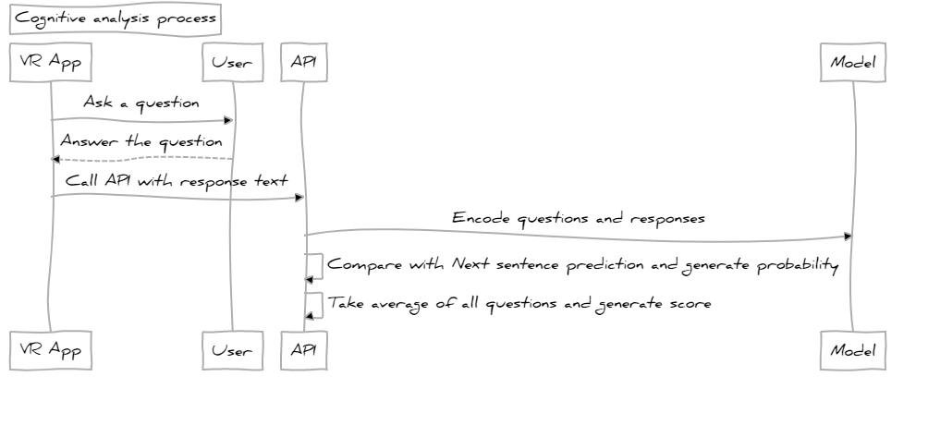**Fig 1. VSCode Sequence Diagram**

**Dataset**

Dataset is created by collecting several sources and medical reports and guides. Below is the dataset at a glance.

<https://docs.google.com/spreadsheets/d/13Zy6_POa8iMN_v9er59_UZ1hCBI9-8Oq/edit#gid=475102244>

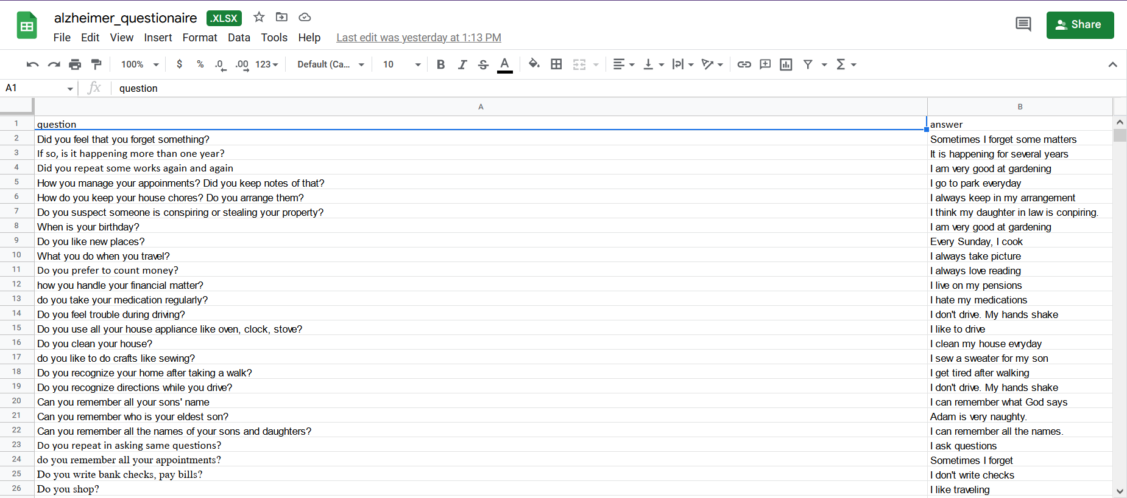

**Git Hub link**

[**elderlycare: Hack-a-roo project for elderly care (github.com)**](https://github.com/dinesh-umkc/elderlycare)

**YouTube Video**

[**https://youtu.be/mGIpDaOUegY**](https://youtu.be/mGIpDaOUegY)

**Unity Project**

[Elderly care - Google Drive](https://drive.google.com/drive/folders/1MFRn76SQIOJnVPhWJRlj8P1SesNFoyXc)

**Technology**

1. Unity
2. Oculus VR headset
3. Android
4. FAST API
5. BERT Next sentence Prediction

**VR App**

1. With VR - Oculus headset, the patient will feel to exist in a hospital environment where the patient will play as an avatar and there is also a doctor avatar.
2. The doctor avatar will ask the patient about memory related questions and patient’s response will be converted from speech to text
3. From the response text of the patient, coherence and cognitive ability will be evaluated in the backend part.

**Rest API**

Rest APIs are developed using Fast API.

1. /questions (GET) API

This API provides random questions to api invoker from pre-defined question set

1. /answers (POST)API

This API accepts questions and answers from api caller and compute similarity score and respond with cognitive score.

**Model**

1. Class used –BertForNextSentencePrediction
2. Model name - bert-base-cased
3. Tokenizer – BertTokenizer

**Results**

Accuracy of Model – 72.91%

**Conclusion**

We created the VR application in the front end part and did the speech to text conversion of the patient and transferred it to the backend portion. In the backend part, Fast API is implemented with BERT transformer for next sentence prediction and we get 72.91% accuracy. For our future prospects, we will implement add on for Parkinson’s disease and add on for doctors to get a customized database for each individual.

**Reference**

[1]<https://www.kaggle.com/code/tanmay111/youtube-comments-sentiment-analysis/data>

[2] [Assessing Cognitive Impairment in Older Patients | National Institute on Aging (nih.gov)](https://www.nia.nih.gov/health/assessing-cognitive-impairment-older-patients)